Public Employee Relations Board Institute of Labor Relations
Presents
Second Tuesdays at PERB
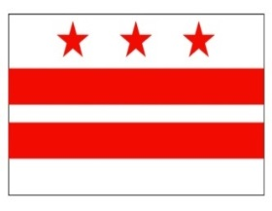

MAKING COLLECTIVE BARGAINING WORK FOR YOU
– THE ETHICS AND CIVILITY OF LABOR RELATIONS -

Tuesday, May 8, 2018
10:00 a.m. – Noon
1100 Fourth Street, SW
Room 850E

An Open Forum will follow during which you will be able to raise any PERB related issues.

Please Note: Pre-registration is required. Register by sending an email to Najibah.Almahdi@dc.gov, including your name, agency or union affiliation. You will be notified if you are registered for the training. Space is limited and early registration is recommended.

