Public Employee Relations Board Institute of Labor Relations
Presents
Second Tuesdays at PERB

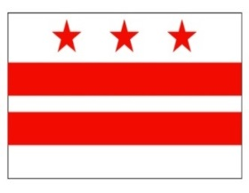

Duty to Bargain: Information Requests

handout attached/bring notebook and hand-out to class

Tuesday, February 14, 2017

10:00 a.m. – Noon

1100 Fourth Street, SW

Room E850

Washington, D.C. 20024

PLEASE NOTE: Pre-registration is required. Register by sending an email to Sheryl.harrington2@dc.gov. Include your name and your agency or union affiliation in your registration email, and whether you will be attending the morning or afternoon session. You will be notified if you are registered for the training. Space is limited and early registration is recommended.

* John E. Higgins, Jr., the instructor, is a former Board Member and Acting General Counsel of the National Labor Relations Board. As a Distinguished Lecturer, he currently teaches “Labor Relations in the Public Sector” and “NLRB Practice and Procedure” at the Catholic University School of Law. His publications include The Developing Labor Law (Editor-in-Chief, 5th and 6th editions), Outline of Law and Procedure in Representation Cases, and How to Take a Case Before the NLRB (supplement to the 8th edition).

