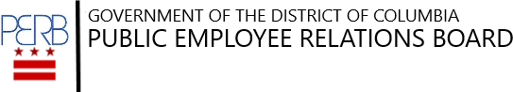

2nd Tuesdays at PERB
Subjects of Bargaining
Tuesday, December 12, 2023
10:00 a.m. – Noon

via WebEx

Register by sending an email to gertie.elam@dc.gov including your name, agency, or union affiliation (if applicable). The WebEx link will be sent following registration.

John E. Higgins, Jr., the instructor, is a former Board Member and Acting General Counsel of the National Labor Relations Board. As a Distinguished Lecturer, he currently teaches “Labor Relations in the Public Sector” and “NLRB Practice and Procedure” at the Catholic University School of Law. His publications include The Developing Labor Law (Editor-in-Chief, 4th, 5th, 6th and 7th editions), Outline of Law and Procedure in Representation Cases, and How to Take a Case Before the NLRB (supplement to the 8th edition).

1100 Fourth Street, SW, Suite E630, Washington, D.C. 20024 • Telephone: (202) 727-1822 fax: (202) 727-9116 • Email: perb@dc.gov • Website: perb.dc.gov

